**World-class manufacturing**

World-class manufacturing is achieved by those companies which are best in the field at each of the competitive priorities such as quality, price, delivery speed, delivery reliability, flexibility, and innovation. A company can no longer dominate a market with access to cheaper man power, newer technology, convenient capital, or a particular supply chain. Now everyone can access anything from anywhere, and it impacts the entire product development process. Any company in the world now can gather the resources from anywhere, compete for any product, and any market! How would a company be able to compete in such a global environment? The answer is simple. To compete globally, one needs to have the ability to gather global resources efficiently and effectively in all of the operating processes.

The solutions to stay competitive in such a global market environment are still the modern technologies, and this point has been proven in industry. While these products have various functional requirements, product cost, quality, and time-to-market are the three key factors in product development.

***Source Internet***

**World class manufacturing is a collection of concepts, which set standard for production and manufacturing for another organization to follow. World class manufacturers tend to implement best practices and also invent new practices as to stay above the rest in the manufacturing sector**. The main parameters which determine world-class manufacturers are quality, cost effective, flexibility and innovation.

**What is product definition?**

Product definition simply means ‘‘figuring out what to make before making it.’’

A product definition is a layout of what the purpose of the product is, whom it is targeted toward, and how it will be built and manufactured.

* design for assembly (DFA), design for manufacturing (DFM)

**PROTOTYPE DESIGN AND INNOVATION**

Design is to invent

Product prototyping can be used as an evaluation tool in the engineering design process. Prototyping plays a key role in product innovation. Prototyping helps to quickly develop a product by providing a good tool for problem solving and can validate a concept. Also, a prototype can play a vital role in innovation because it can be used as a visual to help communicate the product’s purpose and feel. By further develop new product. doing this, different teams can look at the prototypes and use them as a stepping stone to.

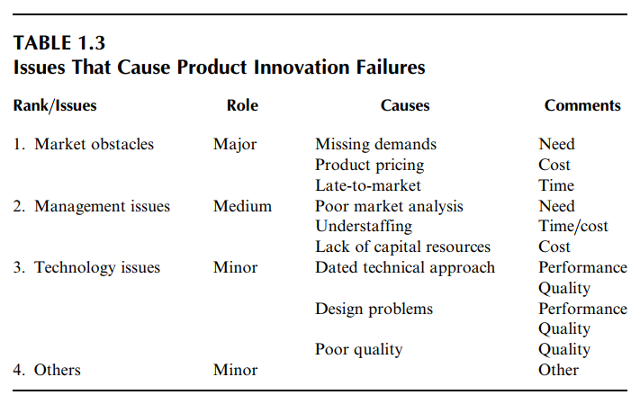It is a science since design can be learned through design methodologies and techniques; however, it is an art because it can only be learned by doing design to gain experience. Just like learning to cook

**IMPACT ON COST, QUALITY, AND TIME**

The direct impact of a shorter product development time includes the opportunity to sell the product at premium prices early in the life cycle, and enjoy longer market life cycle. In addition, the benefits include faster breakeven on development investment and lower financial risk, which leads to greater overall profits and higher return on investment (ROI). Figure 1.2 further illustrates this concept.

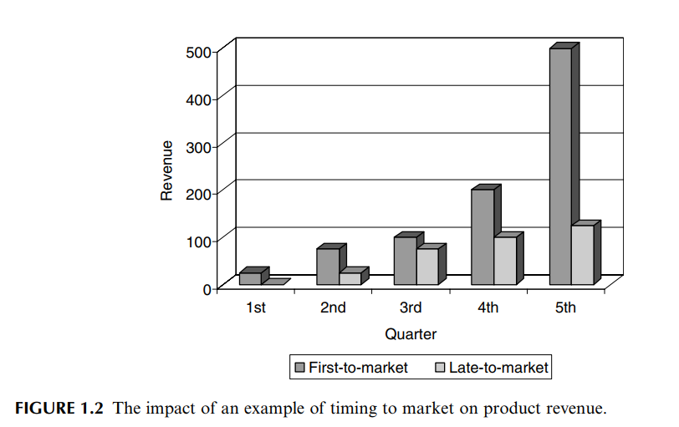

(Development cost) = (Time-to-market) * (Annual development cost)

As time-to-market can significantly impact product development cost and can even be more critical to the ROI, it is the most important factor which needs to be addressed. The critical issues in innovation are related to cost, quality, and time-to-market. Product definition is key to the success in the product development process, and among the activities, prototyping is the most time-consuming task. Design is an iterative process in which two or more iterations may be needed. This makes the prototyping task even longer. It is therefore very critical to be able to reduce prototyping time to shorten the entire product development cycle.

**KEY PROCESS REQUIREMENTS FOR RAPID PROTOTYPING**

Traditional design ideologies require that engineers construct a variety of physical prototypes to test and evaluate design concepts. Due to the nature of such a process, the design and analysis of new products can become very time-consuming and expensive. Therefore, a traditional product design approach often yields very long product development time. Currently, new technologies involving rapid and virtual prototyping are revolutionizing the way products are designed.

Virtual prototyping, for example, integrates digital technologies such as computer-aided design (CAD), computer-aided engineering (CAE), and computer-aided manufacturing(CAM) data, into a single visual environment for viewing and analysis. It provides flexibility, cost-efficient data integration, and a concurrent approach to engineering. The traditional prototyping techniques were successful in the design and analysis of products consisting of less than 100 components. However, when companies are building large assemblies, they face a bigger challenge in the managing of their products, and virtual prototyping technologies have proven to be very effective.

Be first-to-market and you will own the market

**PRODUCT PROTOTYPING AND PRODUCT DEVELOPMENT**

**WHAT IS PROTOTYPING?**

All Simulations virtual prototyping, and rapid prototyping activities are all part of the product prototyping activities. Prototyping has huge implications on product cost, quality, and time.

It is to study the function of the product, the appearance or ‘‘feel’’ of a product, to visualize improvements to a product.

Depending on various prototyping applications, prototyping methods can be classified into physical or analytical methods. For example, simulation approach is an analytical method, and a clay mock-up is a physical prototype. From a different angle, prototypes can also be classified as comprehensive or focused prototypes. For example, when a prototype is used to test the ‘‘look’’ of a product, this prototype may be made from Styrofoam for the purpose, and thus it is a look focused prototype. On the contrary, a full vehicle prototype built to test its full functions would be a comprehensive prototype. Prototypes can be a source of creativity, and they allow the user to interact with the product so the developer can receive feedback.

* Traditional prototyping methods allowed the engineers to create only a static mock-up of what the interface looked like. It was not a dynamic process and the prototypes were not alive enough to enable the designer to test the real world usage of the product.
* Engineers had to use manual tools to create prototypes but since these tools were manual, it is difficult to show all user requirements with a single prototype. That is why the designers, most of the time, had to develop separate prototypes for the same end product to be able to see various user requirements.
* Since the traditional prototyping methods did not allow the designer to reflect all user expectations with one prototype, the process became very costly and time-consuming.
* Traditional prototyping did not give the engineer a chance to make the process iterative enough to involve all stakeholders including the users. Therefore, this situation impacted the quality of the end product.

The traditional options could include building a model from clay, carving from wood, bending wire meshing, carving from Styrofoam perhaps with surface reinforcement, and milling from a block of plastic or aluminum. However, often these methods are time consuming and sometimes lack the quality to serve its purpose such as parts fitting.

In order to effectively evaluate the alternative design concepts in the product definition stage, modern prototyping techniques, such as virtual prototyping and rapid prototyping, are needed for world-class product development.